CURRICULUM VITAE
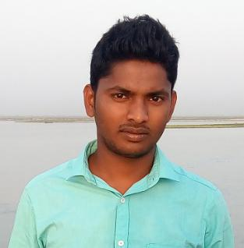

Nagaraju Munga (Nagesh)
Nellimarla MD,
Vizianagaram-535217,
Andhra Pradesh.
Mobile: +91-996-372-0156, +91-729-292-5298
Email:nagesh2andhra@gmail.com, m2m.nag@gmail.com
Career Objective:
To work in a competitive organizational environment where there is scope for the enhancement of personal and professional skills there by contributing to organizational growth and success.

Educational Qualification:

- Class 12 (Science Stream) from National Institute of Open Schooling, Bhubaneswar in year 2011 (secured 78%).
- Class 10 from Kendriya Vidyalaya No3, Bhubaneswar in the year 2009.(secured 89.8%).

Computer Proficiency:
MS-office with basics of Internet applications and computer languages i.e. C, C++.
Working Experience:

- Worked as Team Member in KFC. My Job Profile covers arranging the dining room, welcoming and serving Restaurant guest and tidying the dining room after meal service.
- Worked as Restaurant Manager in Dosa Plaza, City Centre Mall, Nashik.
- 1 Year as a Front Office Assistant in the Chumbi Mountain Retreat and Spa, Pelling, Sikkim.
- Currently working as Front Office Executive in Hotel Galaxy, Rajkot
Job Profile(FOE):
- Greeting, registering, and assigning rooms to guests.
- Issuing room key to guest. Responsible for proper key control and other security measures.
- Answering telephone, Date stamping, sorting, and racks incoming mail and messages.
- Answering inquiries pertaining to hotel services, registration of guests, shopping, dining, entertainment, and travel directions.
- Keeping records of room availability and guests’ accounts. Operates the front office computer system.
- Computing bill, collects payment, and makes change for guests.
- Making and confirming reservations.
- Making restaurant, transportation, or entertainment reservations for guests.
- Checking out guests and inquires about their stay.

Key skills:
- Strong motivational and influential people skills.

- Enthusiasm for creating delicious food and providing a great service.
- An eye for detail and the ability to drive consistent brand standards.
- Experience of managing people and driving business performance.
- Experience of organizing private functions including parties and weddings etc.

Personal Details:
Name: Nagaraju Munga
Father’s Name: M Venkat Rao
Date of Birth: 30 SEP 1992
Address: Door No-6/136, Telakala Street,
Infront of Shri Ram Mandir,
Nellimarla MD,
Vizianagaram-535217,
Andhra Pradesh.
Sex: Male
Religion: Hinduism

Declaration:

I, hereby declare that the information furnished above is true to the best of my knowledge.

Date: Signature:_____________________

